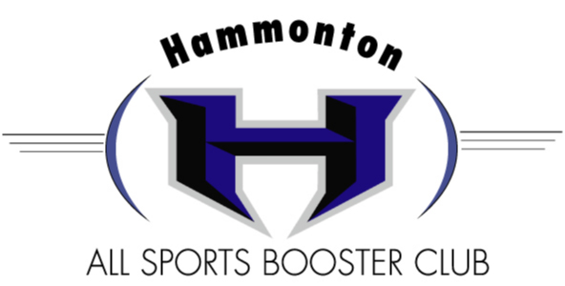

Your tax deductible donations are as follows:
1/8 Page $30.00
¼ Page $50.00
½ Page $75.00
*Full Page (8 ½ X 11) $125.00

Special Patrons
*Back Cover (color) $250.00 *Inside front or back (color) $200.00
These requests are filled on a first come, first served basis
*All Full Page Ads will be announced at every home football game

Please send Ad Request Forms by August 24th to:
kadamucci@hammontonps.org
and/or Send with payment to:
HHS All Sports Booster Club
P.O. Box 344
Hammonton, NJ 08037

If your company has supported the Booster Club in the past, a copy of your ad is on file. If you would like to make changes, please make them on the enclosed copy and return. If you are a new subscriber, we welcome your support. Be sure to include a logo/business card to be used for your advertisement. (Please feel free to use a coupon in your advertisement)

On behalf of the Hammonton High School All Sports Booster Club
and all of the students who benefit from its proceeds, we thank you! Best wishes for a successful business year.
Questions contact: Kellie Adamucci 609-576-5125
kadamucci@hammontonps.org

Sincerely,
Hammonton All Sports Booster Club
GO DEVILS!
AD REQUEST FORM

Business Name________________________________ Contact Name_________________________________
Business Email_____________________________________________________________________________
Business Address_____________________________________ Phone # ______________________________
__________New subscriber w/ logo or business card enclosed
__________Previous supporter, ad w/ changes enclosed
__________Previous supporter, no changes to ad

AD SIZE ___________ Payment enclosed _______________________

